**ASSIGNMENT-8.2**

1. Find the number of students who scored less than 5(50%).

* Filtering by grade
* 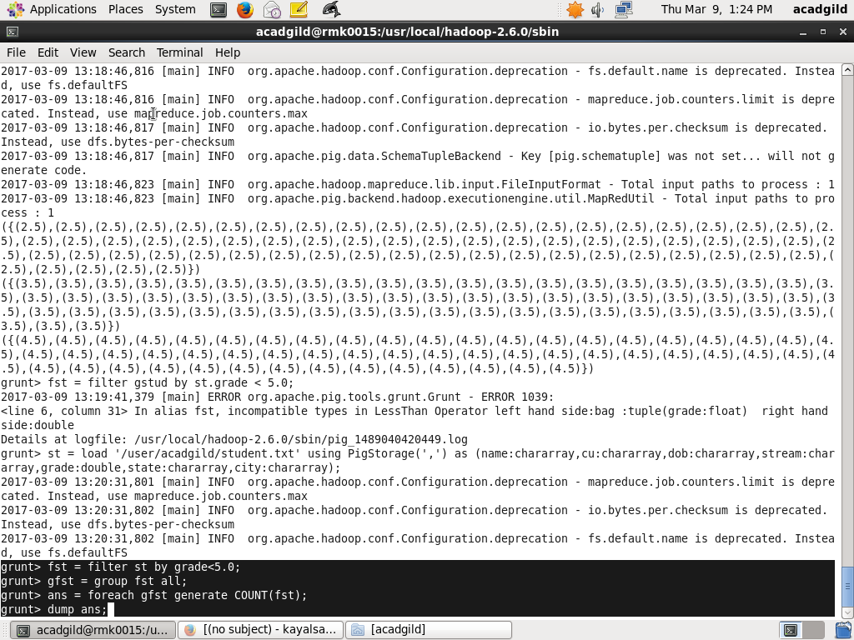grouping the data
* Generate the count

**Output**

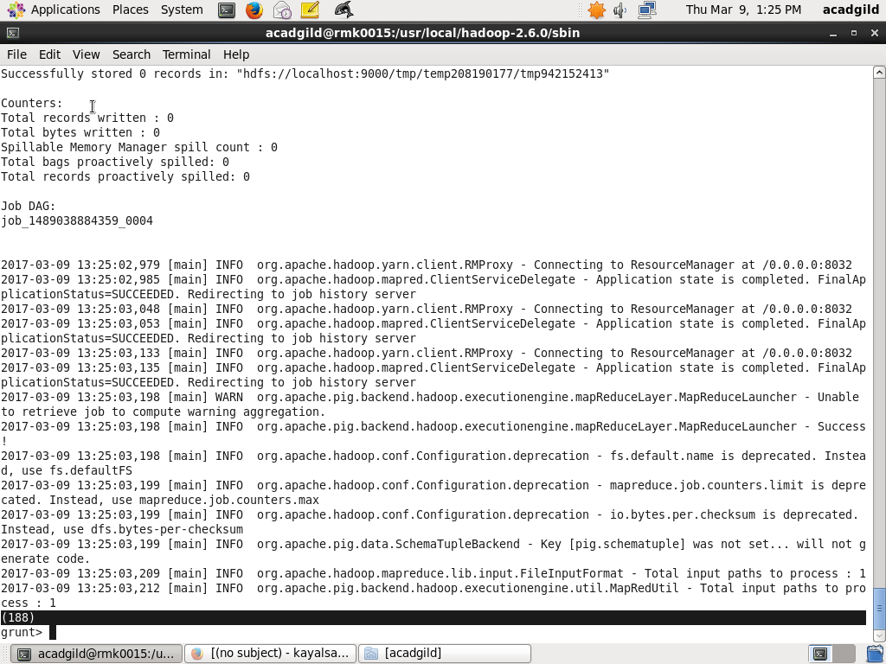

1. List the name of students who are from Alaska.

* Filtering by state
* Generate specific names

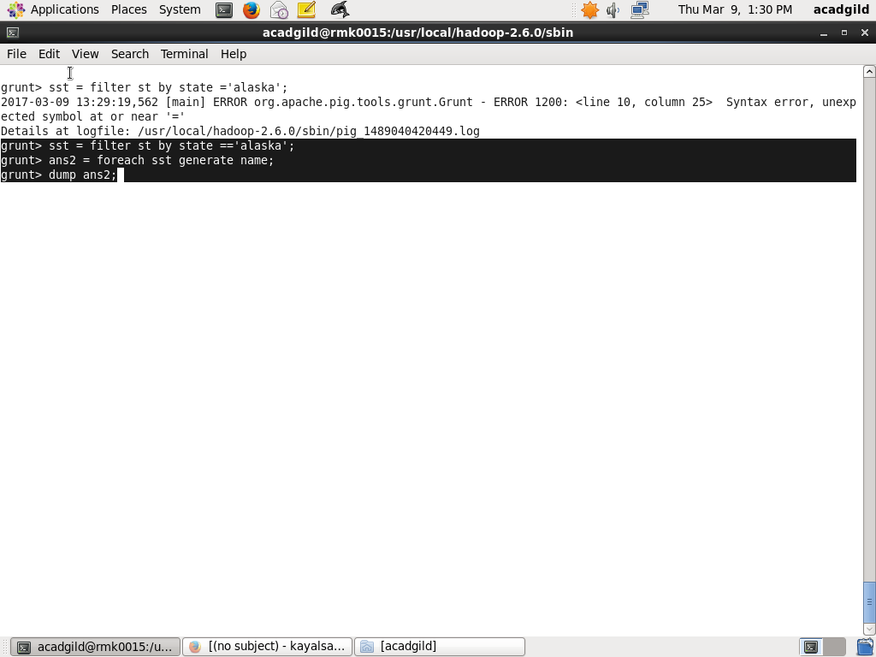

**Output**

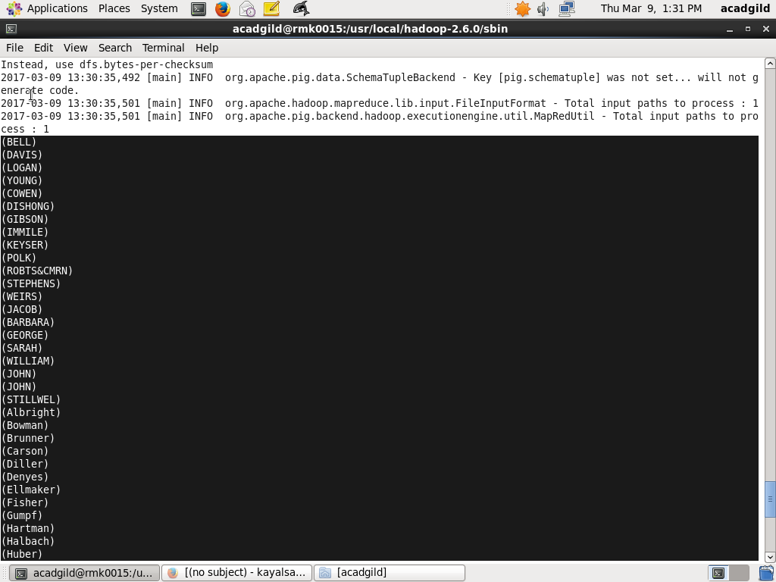

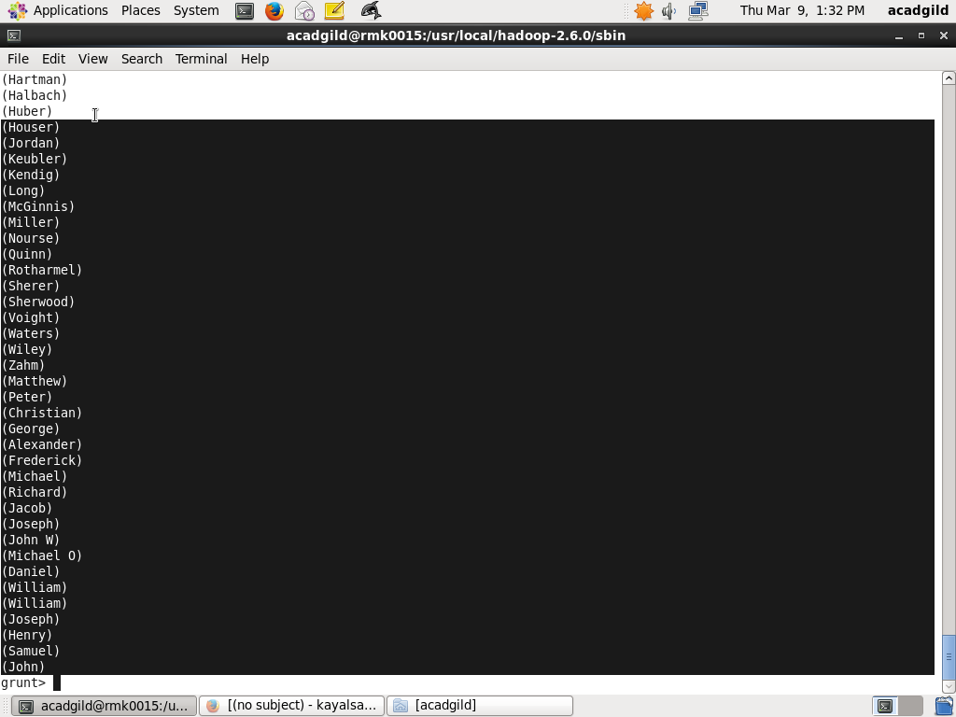

1. How many government colleges are there in Alabama?

* Filter by state Alabama
* Filter by government
* Group data
* Generate its count

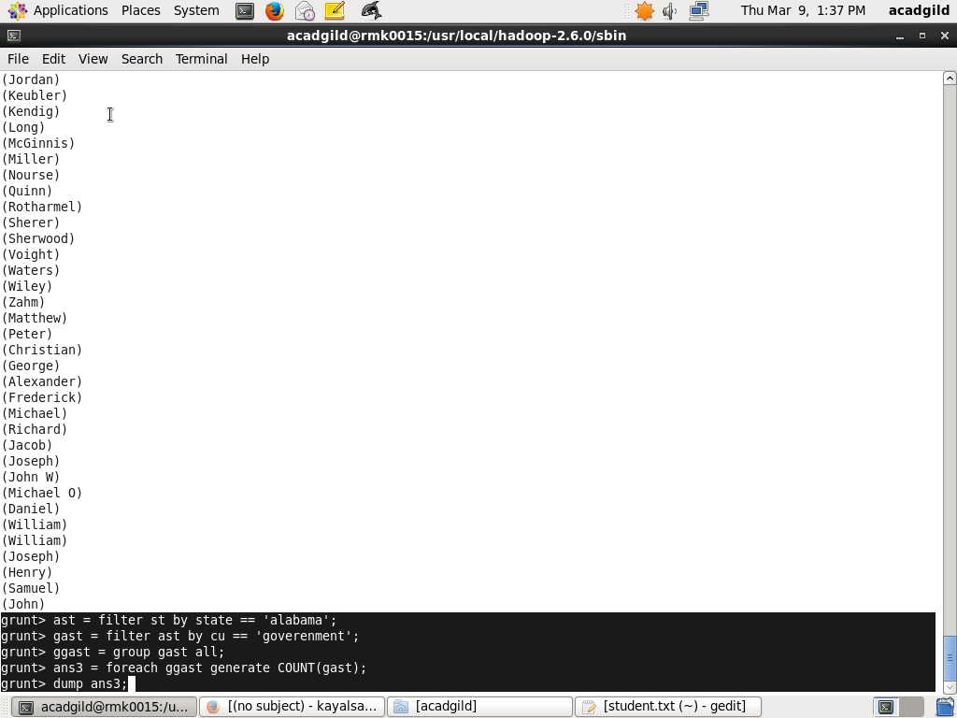

**Output**

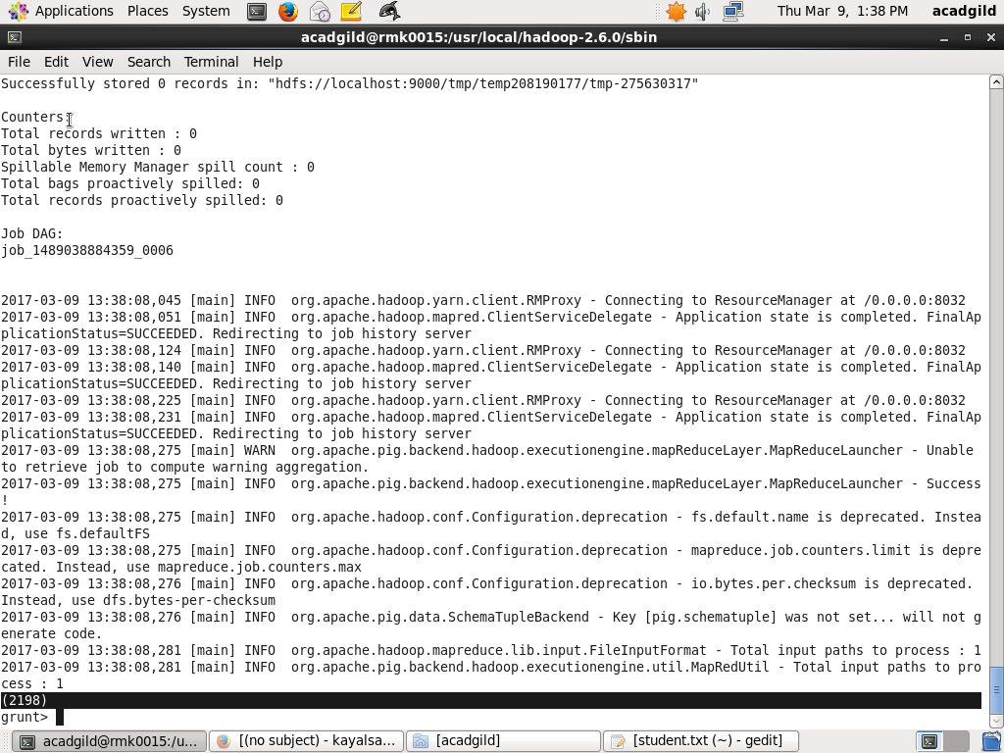

1. List the name of students who are from Oregon and pursuing BE.

* Filter by stream BE
* Filter by state oreogon
* Generate specific name

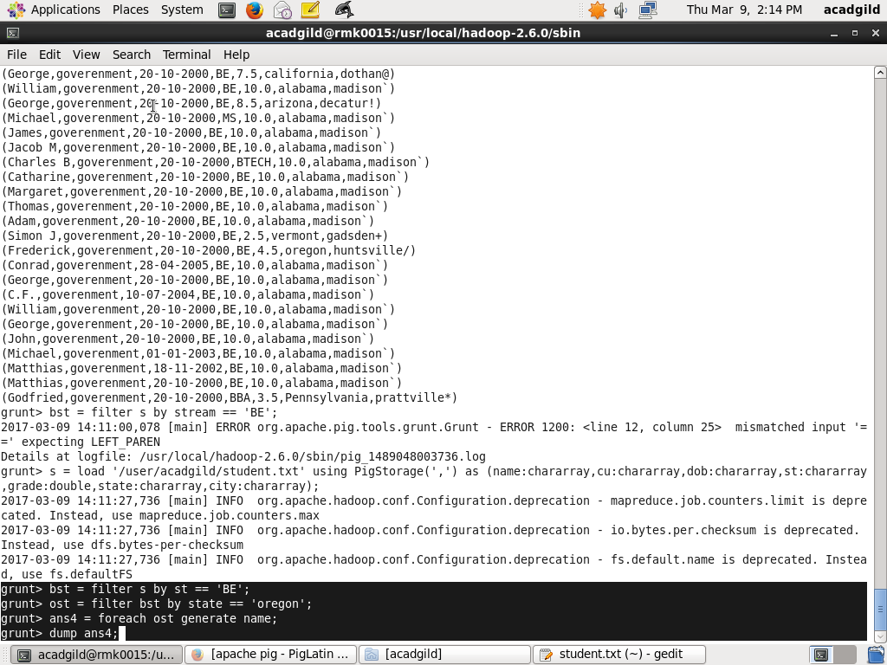

**Output**

